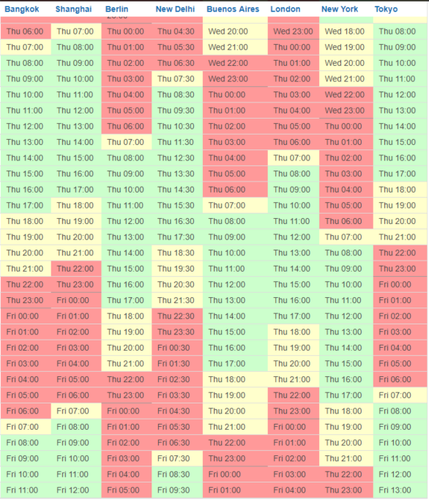Background:

Working as an assistant, you particularly enjoy the international work environment, which often requires you to interact with other assistants abroad. In the meantime, you also got used to working with different time zones; however, sometimes you still need to refer to helpful tools, such as the Time Zone Converter especially when it comes to setting up complex meetings.

**Exercise:**

Your manager has asked you to schedule a 30-minute call with colleagues from Bangkok, Shanghai, Berlin, New Delhi and Buenos Aires for Wednesday, February 15.

They have now responded to you and provided the following slots:

- Lee from Bangkok is available from 3-5 pm local time,

- Lisa from Berlin is available from 9.30-10.30 am local time,

- Maria from Shanghai is available from 5-6 pm local time,

- Amit from New Delhi is available from 1.30-3.00 pm local time.

***Question 1: Using the table below, please find a suitable slot for everyone, including your manager (based in London).***

**Please provide your answer for the UK (London) time zone:** ___________________

**Colors legend:**

Green- local business hours

Yellow- slightly out of business hours

Red- non business hours

***Question 2: Having in mind the timing for the additional, international call you have just calculated, please have a look at your manager’s diary and check if it poses any conflict?***

***Answer: _______________________________________________________________________________***

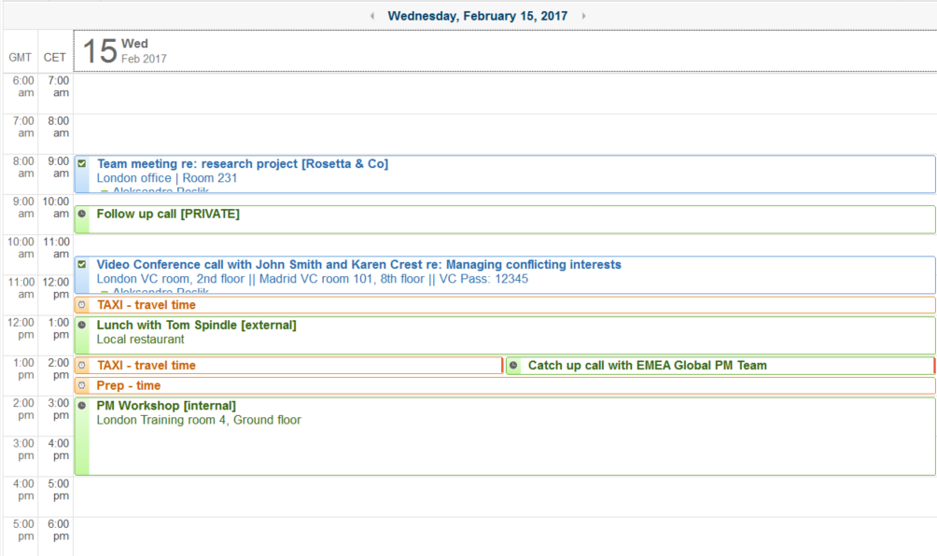

**Answer Key**

Question 1 - London Time: 9 am

Question 2 – 1 conflict, private call could be rescheduled.